NOTICE

BOARD OF EQUALIZATION

Notice is hereby given that the period during which assessment protests can be filed with the County Clerk is
July 2, 2022* through September 15, 2022, at 5:00 p.m.

Applications for changed Assessments are available online at www.alpinecountyca.gov or through the County Clerk's Office, P.O. Box 158, Markleeville, California 96120. You can also telephone 530-694-2281 or e-mail clerk@alpinecountyca.gov to request an application.

The Alpine County Board of Equalization will meet to equalize assessments, as required, at the County Administrative Office Building, 99 Water Street, Markleeville, California, after the deadline for the filing of applications for reduction in assessments. The Board shall continue to meet for that purpose from time to time, until the business of equalization is disposed of.

DATED: 05/31/2022
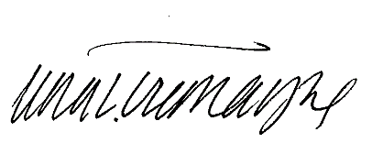

_____________________________________
TEOLA L. TREMAYNE, County Clerk and
ex officio Clerk of the Board of Equalization

*Dates marked with an asterisk fall on a Saturday, Sunday or holiday, and in most cases, the deadline moves forward to the next working day.

