NOTICE OF PUBLIC HEARING

Alpine County Board of Supervisors

Tuesday June 6, 2023 10:00 AM

Alpine County Government Center – Board Chambers

99 Water Street

Markleeville, California

CALIFORNIA WASTE RECOVERY SYSTEMS, LLC (CAL-WASTE)

NOTICE OF HEARING ON PROPOSED RATE INCREASE

Notice is hereby given that a public hearing will be held at or about 10:00 a.m. on June 6, 2023, by the Alpine County Board of Supervisors, at the Alpine County Administration Building, 99 Water Street, Markleeville, California. The hearing will consider a proposed request by Cal-Waste to set residential and commercial solid waste disposal rates. The effective date of the proposed rate increase effective July 1, 2023.

The public hearing will be held during the regular meeting of the Alpine County Board of Supervisors on June 6, 2023 at 10:00 AM, or as soon thereafter as the matter can be heard, at the Alpine County Government Center, Board Chambers, 99 Water St, Markleeville, California.

Members of the public are invited to attend the public hearing. Written comments to be included in the administrative record of the proceedings may be e-mailed to clerk@alpinecountyca.gov or mailed to:

ALPINE COUNTY CLERK
P.O. BOX 158
MARKLEEVILLE, CA 96120

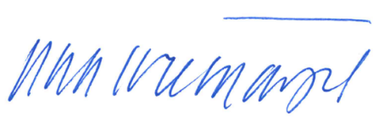
Public input is encouraged.

DATED: May 23, 2023
__________________________________
TEOLA L. TREMAYNE, County Clerk and
Ex officio Clerk of the Board of Supervisors, County of Alpine, State of California

